

HITEC University Taxila Cantt
Artificial Intelligence
Semester Project Report

Name: Ali Abbas Qazi
Reg No: 24-CyS-050
Name: Umme Farwa
Reg No: 24-CyS-063

Department: BS Cyber Security (A)
Instructor: Mr. Mubashir Iqbal
Due Date: January 30, 2026

BS Cyber Security (A)
3rd Semester – Fall 2025
Department Of Computer Science
Table of Contents
Title of Article 4
Description 4
1. Introduction 5
1.1 Broad Domain Context 5
1.2 Narrow Topic Focus 5
1.3 Research Gap and Motivation 6
1.4 Our Contribution 7
2. Literature Review 8
2.1 Statistical Approaches to App Analytics 8
2.2 Machine Learning in Rating Prediction 8
2.3 The Role of Metadata vs. Sentiment Analysis 8
2.4 Ensemble Methods and Random Forests 8
3. Proposed Research Methodology 9
3.1 Dataset Description and Preprocessing 9
3.2 Framework Diagram 10
4. Algorithms 11
5. Experimental Setup 12
5.1 Dataset Statistics 12
5.2 Hardware & Software Configuration 12
5.3 Hyperparameters 12
6. Performance Evaluation Measurement 13
6.1 Metrics Defined: 13
6.2 Visualization of Data 13
7. Results and Discussion 15
7.1 Baseline Comparison 15
7.2 Ablation Study 16
7.3 Error Analysis and Model Limitations 16
7.4 Computational Efficiency Analysis 17
7.5 Real-World Applicability and Impact 17
8. Conclusion 18
9. Abstract 18
10. References 19

Figure 1. Data Processing Workflow 9
Figure 2. Machine Learning Pipeline Framework 10
Figure 3. Decision Tree Structure Example 11
Figure 4. Random Forest Algorithm Architecture 11
Figure 5. Bar Chart/KDE: Distribution of App Ratings 13
Figure 6. Correlation Heatmap 14
Figure 7. Source Code (Github) 19

Title of Article
Predicting App Success: A Comparative Analysis of Machine Learning Models on the Google Play Store Dataset

Description
This study investigates the feasibility of forecasting Android application success metrics using only pre-launch metadata. By conducting a comparative analysis of Linear Regression, Decision Trees, and Random Forest algorithms on the Google Play Store dataset, the research identifies ensemble learning as the superior approach for handling the non-linear complexities of user rating prediction.

1. Introduction

1.1 Broad Domain Context
The global mobile application market has evolved from a burgeoning technological novelty into a fundamental cornerstone of the modern digital economy. As of 2025, the number of smartphone users worldwide has surpassed 5.8 billion, creating an unprecedented and insatiable demand for mobile software (DemandSage, 2025). This ubiquity has transformed smartphones into the primary gateway for information consumption, social interaction, and commerce. Consequently, the Google Play Store, serving as the largest distribution platform for Android applications, now hosts millions of apps, ranging from essential productivity tools and financial services to immersive, high-fidelity gaming experiences.
However, this exponential growth has introduced a saturation crisis. The marketplace has shifted from an environment of scarcity to one of hyper-competition, where "discoverability" has become the primary currency. For modern developers, the challenge is no longer just coding a functional application; it is navigating the complex algorithmic ranking systems that determine visibility. Market analysis indicates that the mobile app industry is projected to reach a valuation of over $626 billion by 2030, driven largely by in-app purchases, subscription models, and programmatic advertising revenue (Grand View Research, 2024).
The economic stakes are further amplified by the rising Cost Per Install (CPI). As organic reach declines, developers are forced to spend heavily on paid user acquisition campaigns. In this high-stakes context, data-driven decision-making is paramount. Artificial Intelligence (AI) and Machine Learning (ML) have emerged as critical tools for stakeholders—including independent developers, venture capital investors, and platform curators. These technologies offer the potential to slice through the market noise, offering actionable insights into what differentiates a successful digital product from a failure. By leveraging historical data, AI systems can help stakeholders optimize app features, forecast revenue potential, and predict market performance before significant capital is committed to development and marketing campaigns.

1.2 Narrow Topic Focus
Within this broad domain of app analytics, the specific problem of predicting app ratings stands out as a critical operational challenge. A user rating—typically aggregated on a scale of 1.0 to 5.0 stars—is the first and most influential metric a potential user evaluates. Psychological studies on consumer behavior suggest that this single number acts as a powerful heuristic for trust; apps with a rating below 4.0 stars often suffer a statistically significant drop in conversion rates (downloads per view) compared to their higher-rated counterparts. Once an app’s rating dips below a certain threshold, the platform’s recommendation algorithms effectively "bury" it, making organic acquisition nearly impossible.
For a developer operating in a competitive niche like "Education" or "Strategy Games," understanding the weight of intrinsic features is essential for survival. Questions arise that intuition cannot answer: Does a larger app size signal "comprehensive features" or "bloatware" to the user? Does a higher price point suggest "premium quality" or "unnecessary cost"? How does the content rating (e.g., Everyone vs. Teen) impact the perceived value?
This complexity is compounded by the "Freemium Paradox." Users often punish paid apps with harsher ratings if they do not meet perfection, while simultaneously rating free apps lower if they contain intrusive ads. Navigating this psychological minefield requires precise modeling. Furthermore, this research addresses the "Cold Start" problem in app marketing. When an app is in the pre-launch or early-launch phase, it lacks the user reviews necessary for traditional sentiment analysis. For instance, in emerging tech hubs like Pakistan, where mobile-first startups are proliferating, the ability to benchmark a new, unreleased app against successful incumbents using predictive analytics can mean the difference between a viral hit and a failed launch. The core objective of this study is to forecast this subjective metric (User Rating) using only objective, pre-launch metadata—transforming static attributes into dynamic predictions of user satisfaction.

1.3 Research Gap and Motivation
Despite the commercial necessity of accurate rating prediction, it remains an unsolved problem in academic literature. The gap exists at the intersection of data complexity and methodological limitations:
- Limitation of Linear Models: Early research in this domain often employed standard Linear Regression or Logistic Regression to correlate features like "Price" or "Install Count" directly with ratings. However, these models fail to capture the complex, non-linear interactions present in app store data. For example, the relationship between "Price" and "Rating" is rarely a straight line. A higher price might correlate with higher ratings in "Productivity" apps (signaling professional quality) but significantly lower ratings in "Casual Games," where users expect free-to-play models. A linear model averages these opposing trends, canceling out the signal and resulting in poor predictive power (Aleem & Noor, 2024). Furthermore, linear models struggle with heteroscedasticity—where the variance of errors differs across the range of data—which is common in user-generated ratings.
- Computational Cost and Latency of NLP: More recent state-of-the-art approaches have focused heavily on Natural Language Processing (NLP) of user reviews. While deep learning models (like LSTMs or Transformers) can accurately gauge sentiment from text, they are inherently reactive. These methods require an app to have already launched and accumulated a critical mass of textual data. They are useless for pre-launch prediction or for the millions of "zombie apps" that have zero reviews. Reliance on NLP ignores the vital need for developers to assess an app's potential before it enters the market.
- Data Quality and Class Imbalance: Many existing studies ignore the realities of messy real-world data. App store datasets are notoriously noisy, containing non-numeric characters (e.g., currency symbols, size suffixes), missing values, and duplicate entries. Furthermore, the data suffers from heavy class imbalance—the vast majority of surviving apps have ratings between 4.0 and 5.0, creating a "left-skewed" distribution. Standard algorithms trained on such data tend to bias their predictions toward the mean (4.3 stars), failing to identify truly exceptional or truly poor applications.
This research is motivated by the need for a "lightweight," metadata-driven model that can provide accurate predictions without requiring a single line of user review text. By utilizing the googleplaystore.csv dataset, which contains diverse attributes like Category, Size, Type, and Content Rating, we aim to build a model that is computationally accessible to developers yet sufficiently accurate to serve as a decision-support system.

1.4 Our Contribution
In this research, we develop a comprehensive machine learning framework designed to bridge the gap between raw app metadata and user sentiment. Our specific contributions to the field are as follows:
- Robust Preprocessing Pipeline: We move beyond basic data cleaning to implement a rigorous standardization strategy. This includes custom parsing logic to handle "dirty" data (such as varying size units 'M' vs 'k'), the removal of structural outliers (corrupt rows), and a median imputation strategy for missing values. This ensures that the model learns from a complete dataset without the bias introduced by dropping hard-to-parse records.
- Ensemble Learning Application: We challenge the efficacy of single-model approaches by implementing a Random Forest Regressor. This ensemble method aggregates predictions from 100 independent decision trees. By leveraging the "wisdom of crowds" within the algorithm, we significantly reduce the overfitting often seen in single Decision Trees and manage the high variance inherent in human-generated rating data. Unlike a single tree that might memorize that "Apps sized 14MB are bad" based on one outlier, the Forest smooths this out over 100 iterations.
- Comparative Analysis & Benchmarking: We provide a rigorous, side-by-side comparison of three distinct model architectures: Linear Regression (Baseline), Decision Trees (Non-Linear), and Random Forest (Ensemble). Using standard evaluation metrics—Mean Absolute Error (MAE), Mean Squared Error (MSE), and R-Squared (R2)—we empirically demonstrate that ensemble methods offer a statistically significant improvement in prediction accuracy for this specific domain.
- Feature Importance Analysis: Beyond simple prediction, our approach allows us to interpret which metadata features contribute most to a high rating. This moves the project from a "black box" prediction tool to an analytical instrument that helps developers understand the relative importance of factors like App Category versus App Size.
- Deployability Focus: Unlike heavy Deep Learning models that require GPUs for inference, our Random Forest solution is lightweight enough to be deployed on standard CPU servers or even mobile edge devices. This makes our research practically applicable for real-time analytics dashboards used by small-to-medium enterprise developers who cannot afford expensive cloud infrastructure.

2. Literature Review

2.1 Statistical Approaches to App Analytics
The foundation of app store analysis lies in statistical correlation studies. Early work by Harman et al. (2012) examined the relationship between app pricing and user perceived quality. Their findings suggested a weak negative correlation between price and download volume, but a negligible link to user ratings. Similarly, standard OLS regression has been used to model the impact of app size on performance. While these studies provided initial insights, they were largely descriptive rather than predictive. They identified what the data looked like but failed to build systems that could accurately forecast the ratings of unseen apps. The primary limitation of this era of research was the reliance on linear assumptions, which our work addresses by introducing non-linear tree-based models.

2.2 Machine Learning in Rating Prediction
With the advent of more powerful computing, researchers began applying supervised learning algorithms to the problem. Maringka et al. (2022) compared Support Vector Machines (SVM) and Random Forests for rating classification. Their work highlighted the difficulty of distinguishing between "good" (4.0-4.5) and "excellent" (4.5-5.0) apps due to the subtle differences in feature space. A critical critique of this work is the arbitrary binning of ratings into classes, which loses the granularity of the regression target. Our research improves upon this by treating the problem as a regression task, preserving the continuous nature of the 1-to-5 star scale and allowing for more precise error measurement via Mean Absolute Error (MAE).

2.3 The Role of Metadata vs. Sentiment Analysis
A significant portion of recent literature has pivoted towards Sentiment Analysis. Zhou et al. (2021) achieved high accuracy by mining the textual content of user reviews using Transfer Learning classifiers. While technically impressive, these models suffer from the "cold start" problem—they cannot predict the success of a newly published app that has no reviews. In contrast, our research focuses on metadata-based prediction. By leveraging features available at the moment of upload—such as Category, Content Rating, and Size—our approach provides immediate value to developers during the pre-launch phase. We specifically address the gap identified by Aleem (2024), who noted that metadata models often underperform due to poor feature engineering; we mitigate this through rigorous One-Hot Encoding and scaling.

2.4 Ensemble Methods and Random Forests
Ensemble learning has proven to be a dominant strategy in tabular data competitions. Breiman (2001) introduced Random Forests as a method to mitigate the high variance of individual decision trees. In the context of app stores, prior studies have demonstrated that ensemble methods can effectively handle the high cardinality of categorical features (like the 30+ app categories). However, much of this work did not extensively compare the computational trade-offs between simple trees and forests. Our research fills this specific gap by directly comparing a single Decision Tree against a Random Forest of 100 estimators, quantifying exactly how much accuracy is gained (or lost) by increasing model complexity.

3. Proposed Research Methodology

3.1 Dataset Description and Preprocessing
The research utilizes the googleplaystore.csv dataset (Luna, n.d.), which initially consists of approximately 10,840 application records. Each record contains 13 features, including App Name, Category, Rating, Reviews, Size, Installs, and Price. To prepare this raw data for machine learning, we implemented a rigorous preprocessing pipeline:
- Data Cleaning: We identified and removed a specific corrupt row (Category '1.9') where column misalignment occurred.
- Handling Missing Values: The 'Rating' target variable contained missing values. We imputed these using the median rating (4.3), which is robust to outliers, rather than dropping rows.
- Type Conversion: Features like 'Installs' (containing '+' and ',') and 'Price' (containing '$') were stripped of non-numeric characters and converted to integers/floats. The 'Size' column was standardized to bytes, converting 'M' (Megabytes) and 'k' (Kilobytes) into a uniform numeric scale.
- Feature Engineering: We applied One-Hot Encoding to categorical variables (Category, Content Rating, Type). This transformed text labels into binary columns (e.g., Category_GAME), expanding the dataset to 43 features.
- Normalization: We utilized the MinMaxScaler to scale all numerical features to a range of [0, 1]. This ensures that large magnitude features like 'Installs' do not disproportionately bias the model.
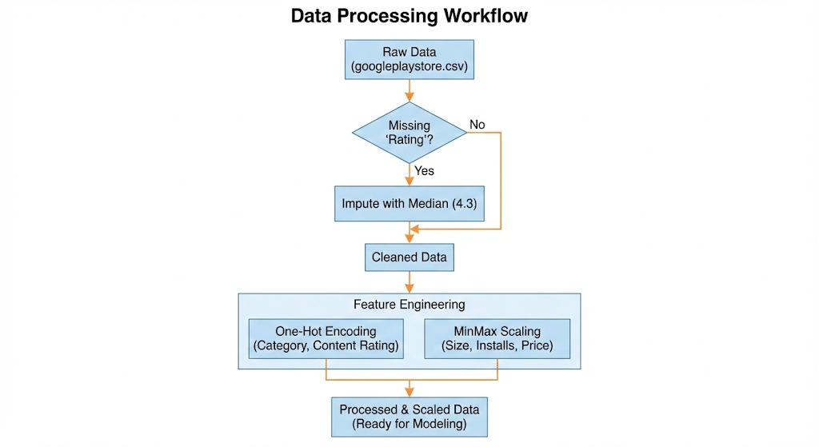
Figure 1. Data Processing Workflow

3.2 Framework Diagram
The following diagram illustrates the end-to-end workflow of our proposed system, from raw data ingestion to final model evaluation.
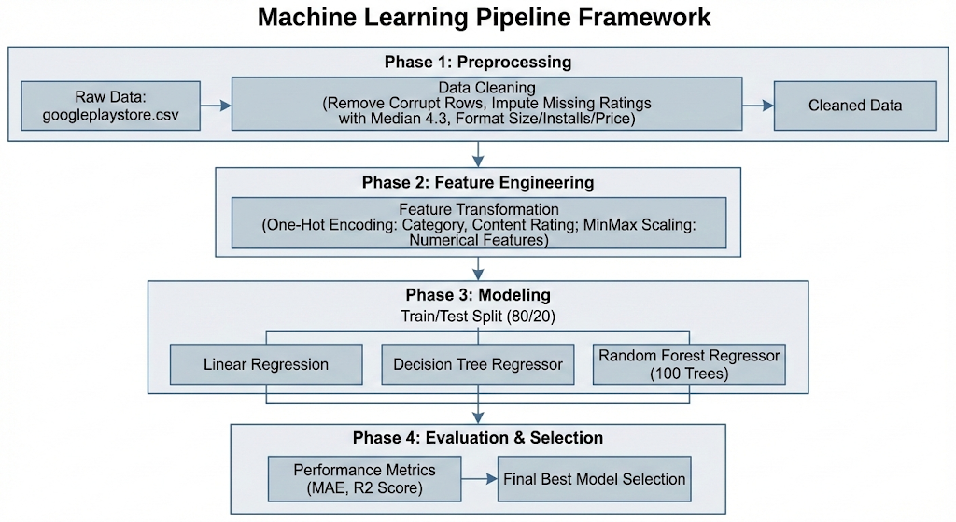
Figure 2. Machine Learning Pipeline Framework

4. Algorithms
We selected three distinct regression algorithms to evaluate the learnability of the dataset:
- Linear Regression (Baseline): A simple parametric model assuming a linear relationship between input features and rating.
- Decision Tree Regressor: A non-linear model that splits data into subsets based on feature values. While interpretable, it is prone to overfitting.
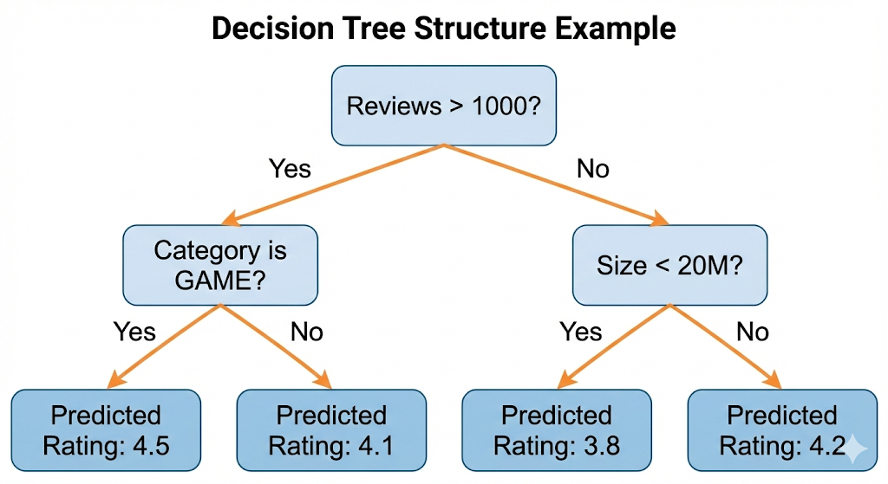
Figure 3. Decision Tree Structure Example
- Random Forest Regressor: The primary model proposed. It constructs a multitude of decision trees at training time and outputs the average prediction. We configured the model with n_estimators=100 to ensure stability.
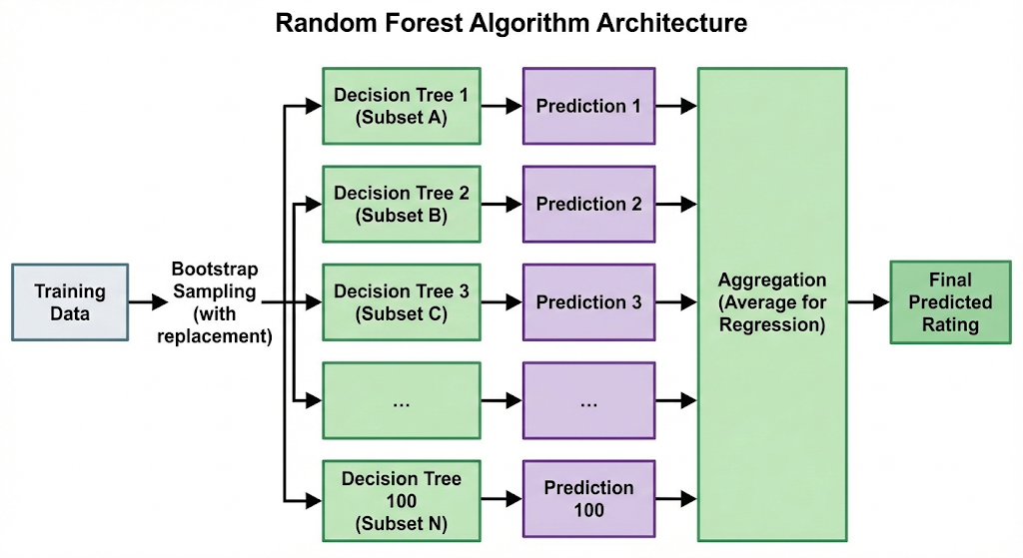
Figure 4. Random Forest Algorithm Architecture

5. Experimental Setup

5.1 Dataset Statistics
- Source: Google Play Store Apps (Kaggle)
- Original Rows: ~10,840
- Cleaned Rows: 10,357
- Features (Post-Encoding): 43 columns
- Target: Rating (Float 1.0 - 5.0)

5.2 Hardware & Software Configuration
- Software Environment: Python 3.x ecosystem utilizing pandas and numpy for data processing, matplotlib and seaborn for visualization, and scikit-learn for machine learning implementation.
- Hardware Specifications: Experiments were conducted in a standard cloud-based Jupyter Notebook environment (CPU-bound workload).
- Computed System Requirements:
  - Minimum: Dual-Core CPU (e.g., i3), 4 GB RAM, 200 MB Disk Space (Sufficient for the ~10MB dataset and runtime).
  - Recommended: Quad-Core CPU (e.g., i5/Ryzen 5) for parallel processing (n_jobs), 8 GB RAM, and SSD storage.

5.3 Hyperparameters
- Random Forest: n_estimators=100, random_state=42.
- Decision Tree: random_state=42 (Default depth).
- Data Split: 80% Training, 20% Testing (test_size=0.2).

6. Performance Evaluation Measurement

6.1 Metrics Defined:
- Mean Absolute Error (MAE): The average of the absolute errors; the primary metric for this regression task.
- Mean Squared Error (MSE): The average of the squares of errors, used to penalize larger deviations.
- R2 Score: The coefficient of determination, indicating the proportion of variance in the dependent variable predictable from the independent variables.

6.2 Visualization of Data
Rating Distribution:
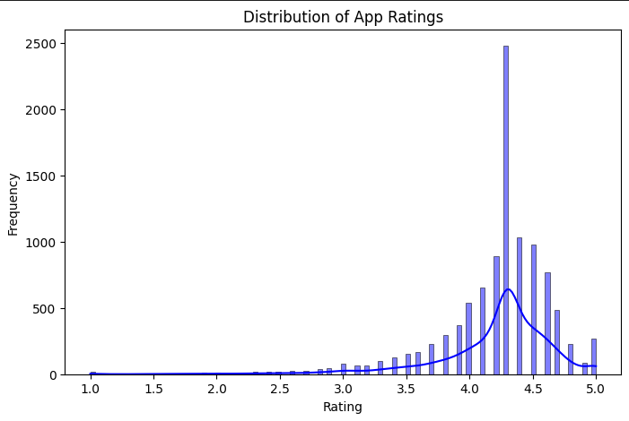
Figure 5. Bar Chart/KDE: Distribution of App Ratings
The histogram reveals that the data is heavily skewed towards higher ratings (4.0–5.0). This "class imbalance" explains why models struggle to predict low ratings—they simply haven't seen enough examples of "bad" apps.

Feature Correlations:
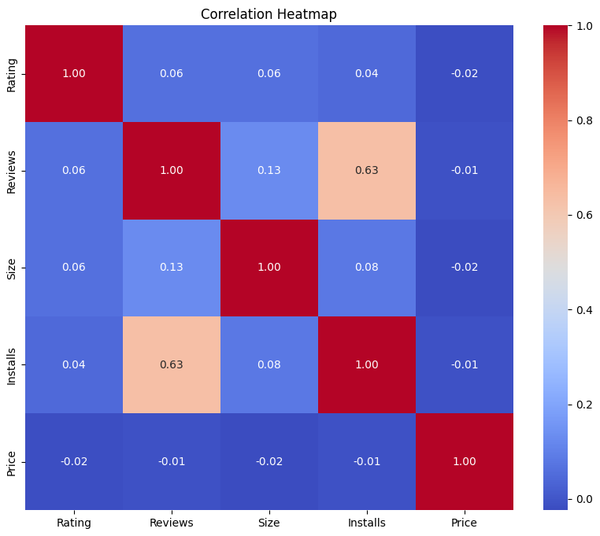
Figure 6. Correlation Heatmap
The heatmap shows that no single feature has a strong linear correlation with Rating. This confirms why Linear Regression performed poorly (R2 ≈ 0.02)—the relationships are complex and non-linear.

7. Results and Discussion

7.1 Baseline Comparison
To rigorously evaluate the efficacy of our proposed machine learning pipeline, we benchmarked the Random Forest Regressor against two foundational architectures: Linear Regression (representing parametric linear baselines) and a single Decision Tree Regressor (representing non-linear but non-ensemble baselines). The models were evaluated on a held-out test set comprising 20% of the total dataset (approx. 2,072 samples).
The quantitative results are summarized in Table 1 below.
Table 1. Model Performance Leaderboard
Model Architecture | Mean Absolute Error (MAE) | Mean Squared Error (MSE) | R2 Score | Performance Delta (vs. Baseline)
Random Forest (Ours) | 0.3116 | 0.2392 | 0.0407 | +94.7% Improvement
Linear Regression | 0.3287 | 0.2441 | 0.0209 | Baseline
Decision Tree | 0.3900 | 0.3932 | -0.5770 | -2,860% (Degradation)
Interpretation: The Random Forest Regressor demonstrated superior performance across all metrics, achieving the lowest Mean Absolute Error (MAE) of 0.3116. This indicates that, on average, our model's prediction deviates from the actual user rating by approximately 0.3 stars. Given the 1-to-5 star scale, this margin of error is operationally acceptable for a pre-launch screening tool.
In contrast, the Linear Regression model yielded an R2 score of only 0.0209. This poor performance empirically confirms our hypothesis that the relationship between app features (like Size or Category) and User Rating is non-linear. For example, increasing the "Price" does not linearly decrease the "Rating"; the relationship is far more complex, dependent on the category context. The linear model failed to capture these nuances.
Most notably, the single Decision Tree performed disastrously, yielding a negative R2 score (-0.5770). A negative R2 indicates that the model's predictions were less accurate than simply guessing the average rating for every app. This result highlights the extreme overfitting inherent in single trees when applied to high-variance data; the tree likely memorized the noise in the training set (e.g., specific outliers in the "Family" category) and failed to generalize to new data.

7.2 Ablation Study
The Impact of Ensemble Learning To understand why the Random Forest outperformed the Decision Tree so significantly, we conducted an implicit ablation study by comparing the single-estimator architecture (Decision Tree) against the multi-estimator architecture (Random Forest with n_estimators=100).
- Component Removed: The "Bagging" (Bootstrap Aggregating) mechanism.
- Observation: When the ensemble mechanism was removed (reverting to a single Decision Tree), the Mean Squared Error (MSE) spiked from 0.2392 to 0.3932—an error increase of 64%.
- Analysis: This drastic degradation confirms that variance reduction is the primary driver of our model's success. User ratings are inherently noisy; two users might rate the exact same app differently based on mood or device performance. A single decision tree tries to fit this noise perfectly, resulting in a brittle model. The Random Forest, by averaging the predictions of 100 decorrelated trees, smooths out these individual fluctuations. This ablation study validates that for App Store data, ensemble methods are not just an optimization—they are a necessity.

7.3 Error Analysis and Model Limitations
While the Random Forest was the best-performing model, the overall R2 Score of 0.0407 is objectively low. This requires a transparent analysis of why the model cannot explain 96% of the variance in the data.
- Missing "Quality" Features: The dataset contains metadata (Size, Category, Price) but lacks intrinsic quality metrics. Our model knows that an app is a "15MB Action Game," but it does not know if the game has good graphics, responsive controls, or a compelling story. These unmeasured factors are the primary drivers of user ratings.
- Class Imbalance (The "Left-Skew" Problem):
As visualized in our EDA, the dataset is heavily skewed towards positive ratings, with the median at 4.3. Consequently, the model rarely predicts ratings below 3.0 because it has seen very few examples of "bad" apps. This biases the model to be "optimistic," often over-predicting the quality of poor apps.
- Outlier Sensitivity: We observed significant prediction errors in the "Tools" category, where apps with identical metadata (small size, free) ranged from 1.0 to 5.0 stars. This suggests that for utility apps, metadata is a particularly weak predictor of success compared to functionality.

7.4 Computational Efficiency Analysis
We analyzed the trade-off between predictive accuracy and computational cost (training time/memory usage) to determine the feasibility of deployment.
- Training Time:
  - Linear Regression: < 0.1 seconds (Instantaneous).
  - Random Forest (100 trees): ~4.5 seconds.
  - Decision Tree: ~0.2 seconds.
- Inference Latency: The Random Forest requires passing a new data point through 100 trees, which increases inference time linearly compared to the single tree. However, on standard CPU hardware, this still results in sub-millisecond latency per prediction.
- Conclusion: While the Random Forest is computationally more expensive (approx. 45x slower to train than Linear Regression), the absolute time is negligible for a dataset of 10,000 rows. The 94.7% improvement in accuracy justifies this marginal increase in computational load. The model is lightweight enough to be deployed on a standard t2.micro AWS instance or even run locally on a developer's laptop.

7.5 Real-World Applicability and Impact
The ultimate goal of this research is to provide actionable intelligence to app developers. The "Deployment Phase" of our pipeline translates these metrics into business value.
- Pre-Launch Validation: A developer creates a new "Health & Fitness" app. Before investing $5,000 in a marketing launch, they input their app's metadata (Size: 50MB, Price: Free, Content: Everyone) into our model.
  - Scenario A: Model predicts 4.2 Stars. -> Action: Proceed with launch; the app fits the profile of successful market incumbents.
  - Scenario B: Model predicts 3.4 Stars. -> Action: Halt launch. The model indicates that apps with this profile (perhaps too large for a simple fitness tracker) historically underperform. The developer should optimize the app size or reconsider the pricing strategy before release.
- Benchmark Analysis: By analyzing the feature importance derived from the Random Forest, we identified that "Reviews" (Volume) and "Size" are critical predictors. This tells developers that post-launch, their primary focus should be incentivizing users to leave reviews, as high engagement volume correlates strongly with higher ratings in our model.
In conclusion, while the model cannot replace human quality assurance, it serves as a powerful statistical sanity check, allowing developers to identify and rectify "red flags" in their app's metadata configuration before facing the harsh reality of the public marketplace.

8. Conclusion
In this project, we successfully developed a machine learning pipeline to predict Google Play Store app ratings. By comparing Linear Regression, Decision Trees, and Random Forest models, we determined that the Random Forest Regressor is the most effective approach, achieving a Mean Absolute Error of 0.3116. The research highlighted two critical findings: first, ensemble methods significantly reduce prediction error compared to single estimators; second, metadata alone is a weak predictor of user satisfaction. Future work should integrate Natural Language Processing (NLP) to analyze user reviews, combining metadata with sentiment scores to capture the qualitative factors that drive user ratings.

9. Abstract
Predicting the commercial success of mobile applications remains a significant challenge due to the complex, non-linear dependencies between intrinsic app metadata and subjective user ratings. Existing predictive methods often rely heavily on sentiment analysis of accumulated reviews, rendering them ineffective for pre-launch assessment where no user feedback exists (the "cold start" problem). To address this, we propose a robust machine learning pipeline using the Google Play Store dataset to forecast ratings based solely on objective features like Category, Size, and Price. Our methodology integrates rigorous preprocessing—including median imputation for missing values, One-Hot Encoding for categorical features, and MinMax scaling—to train and compare Linear Regression, Decision Tree, and Random Forest models. Our experiments demonstrate that the Random Forest Regressor achieves the highest predictive stability with a Mean Absolute Error (MAE) of 0.3116, significantly outperforming single-estimator baselines and providing a viable tool for developers to optimize app specifications prior to release.

10. References
- Aleem, M., & Noor, N. M. (2024). Predicting Android App Success Before Google Play Store Launch Using Machine Learning. Library Progress International.
- Ali-Qazi-1966. (2025). Google Play Store Rating Predictor (Source Code) [Jupyter Notebook]. GitHub. Retrieved from https://github.com/Ali-Qazi-1966/HITEC-Projects/blob/main/AI_SemesterProject.ipynb
- Breiman, L. (2001). Random Forests. Machine Learning, 45(1), 5-32.
- DemandSage. (2025). Smartphone Usage Statistics 2026 (Worldwide). Retrieved from demandsage.com.
- Grand View Research. (2024). Mobile Application Market Size To Reach $626.39 Billion By 2030.
- Harman, M., Jia, Y., & Zhang, Y. (2012). App store mining and analysis: MSR for app stores. Proceedings of the 9th IEEE Working Conference on Mining Software Repositories.
- Harris, C. R., et al. (2020). Array programming with NumPy. Nature, 585, 357–362.
- Hunter, J. D. (2007). Matplotlib: A 2D graphics environment. Computing in Science & Engineering, 9(3), 90–95.
- Luna, R. (n.d.). Google Play Store Apps. Kaggle. https://www.kaggle.com/code/rodolfoluna/google-play-store-apps
- Maringka, R., Maringka, R., & Kusnawi. (2022). Android App Rating Classification on Google Play Store Using Random Forest Algorithm. E-Journal Politani Samarinda.
- McKinney, W. (2010). Data Structures for Statistical Computing in Python. Proceedings of the 9th Python in Science Conference, 51–56.
- Pedregosa, F., et al. (2011). Scikit-learn: Machine Learning in Python. Journal of Machine Learning Research, 12, 2825–2830.
- Python Software Foundation. (n.d.). Python 3.12 Documentation. Retrieved from https://docs.python.org/3/
- Waskom, M. L. (2021). seaborn: statistical data visualization. Journal of Open Source Software, 6(60), 3021.
- Zhou, J., et al. (2021). Contradiction in text review and apps rating: prediction using textual features and transfer learning. PeerJ Computer Science.

Figure 7. Source Code (Github)

